Unit 2
Cloud Service and Deployments Models

(7 Hours)

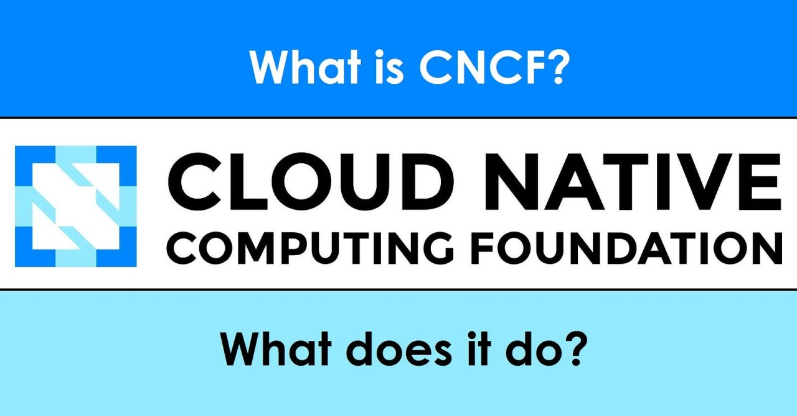
. 2.1 Cloud service models:
. IaaS
. PaaS
. SaaS
. 2.2 Deployment models:
. Public cloud
. Private cloud
. Hybrid cloud
. Community cloud
. 2.3 Comparison of service models
. 2.4 Shared responsibility model
. 2.5 Selection criteria
. 2.6 Multi-cloud concepts
. 2.7 Vendor lock-in issues
. 2.8 Serverless computing and event-driven architecture

. 2.1 Cloud service models:
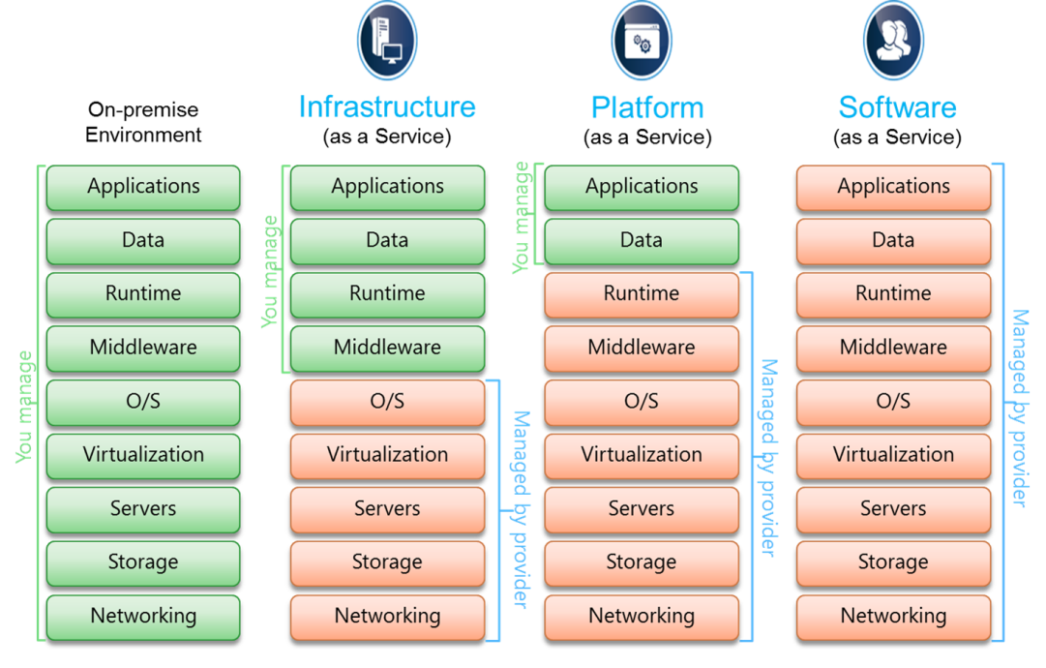
Cloud service models explain what type of cloud service is provided to users.
The three major cloud service models are:
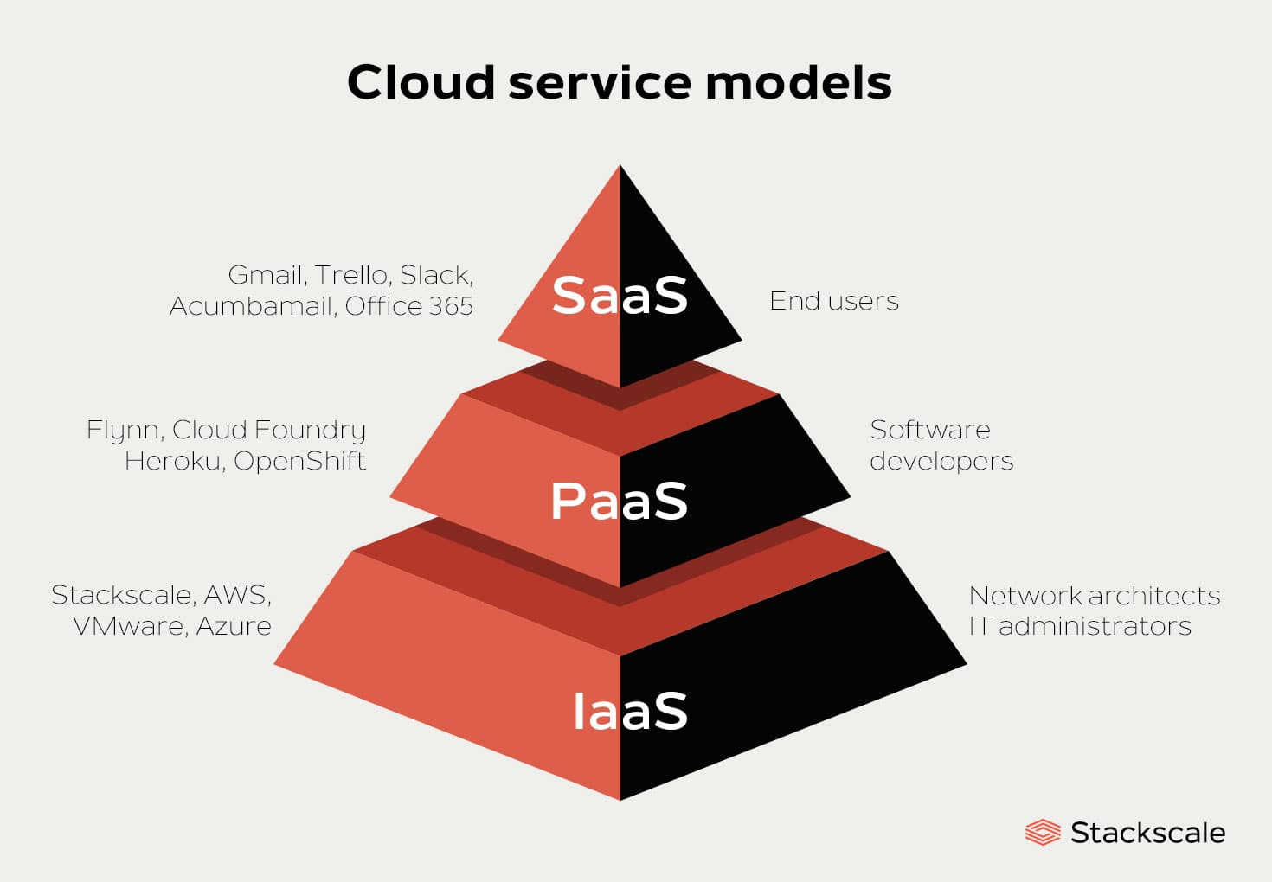
. IaaS: Infrastructure as a Service
. PaaS: Platform as a Service
. SaaS: Software as a Service

A. IaaS: Infrastructure as a Service
Meaning
IaaS provides basic computing infrastructure through the internet.
In IaaS, cloud provider gives:
. Virtual machines
. Storage
. Network
. Firewall
. Load balancer
. IP address
The user manages the operating system, applications, database, and security configuration.

Simple Example
A company needs a server to host its website.
Instead of buying a physical server, the company rents a virtual machine from a cloud provider.
Examples:
. AWS EC2
. Microsoft Azure Virtual Machine
. Google Compute Engine
. DigitalOcean Droplet
. Linode VM

IaaS Responsibility Example
Component | Managed By
Physical server | Cloud provider
Data center | Cloud provider
Network hardware | Cloud provider
Virtualization | Cloud provider
Operating system | Customer
Application | Customer
Data | Customer

IaaS Data Example
A startup needs 3 servers:
Server | CPU | RAM | Storage | Purpose
VM-1 | 2 cores | 4 GB | 80 GB | Web server
VM-2 | 4 cores | 8 GB | 160 GB | Application server
VM-3 | 4 cores | 16 GB | 250 GB | Database server
Instead of buying 3 physical servers, the startup rents 3 cloud VMs.

IaaS Cost Example
Assume cloud VM cost:
Small VM = Rs. 5/hour
Medium VM = Rs. 10/hour
Large VM = Rs. 20/hour
Monthly usage = 720 hours.
VM Type | Quantity | Cost/Hour | Monthly Cost
Small VM | 1 | Rs. 5 | Rs. 3,600
Medium VM | 1 | Rs. 10 | Rs. 7,200
Large VM | 1 | Rs. 20 | Rs. 14,400
Total monthly cost:
3,600 + 7,200 + 14,400 = Rs. 25,200

Advantages of IaaS
. High control over server
. Flexible resource allocation
. Suitable for custom applications
. Easy scaling
. No need to buy physical hardware

Disadvantages of IaaS
. Customer must manage OS and security
. Requires technical knowledge
. Misconfiguration risk
. Cost can increase if resources are not monitored

Best Use Cases of IaaS
. Hosting custom web applications
. Running databases
. Disaster recovery
. Testing and development servers
. Migrating old applications to cloud

B. PaaS: Platform as a Service
Meaning
PaaS provides a ready-made platform for developers to build, test, deploy, and manage applications.
In PaaS, the cloud provider manages:
. Server
. Operating system
. Runtime environment
. Middleware
. Database platform
. Scaling platform
The developer mainly focuses on application code.

Simple Example
A developer creates a Python web application. Instead of managing Linux server, Python installation, web server, and scaling manually, the developer deploys code to a PaaS platform.
Examples:
. Google App Engine
. Heroku
. Azure App Service
. AWS Elastic Beanstalk
. Render
. Railway

PaaS Responsibility Example
Component | Managed By
Data center | Cloud provider
Server hardware | Cloud provider
Operating system | Cloud provider
Runtime | Cloud provider
Application code | Customer
Application data | Customer

PaaS Example Scenario
A college wants to build an online admission form.
The developer writes:
. Form page
. Validation logic
. Database connection
. Email notification logic
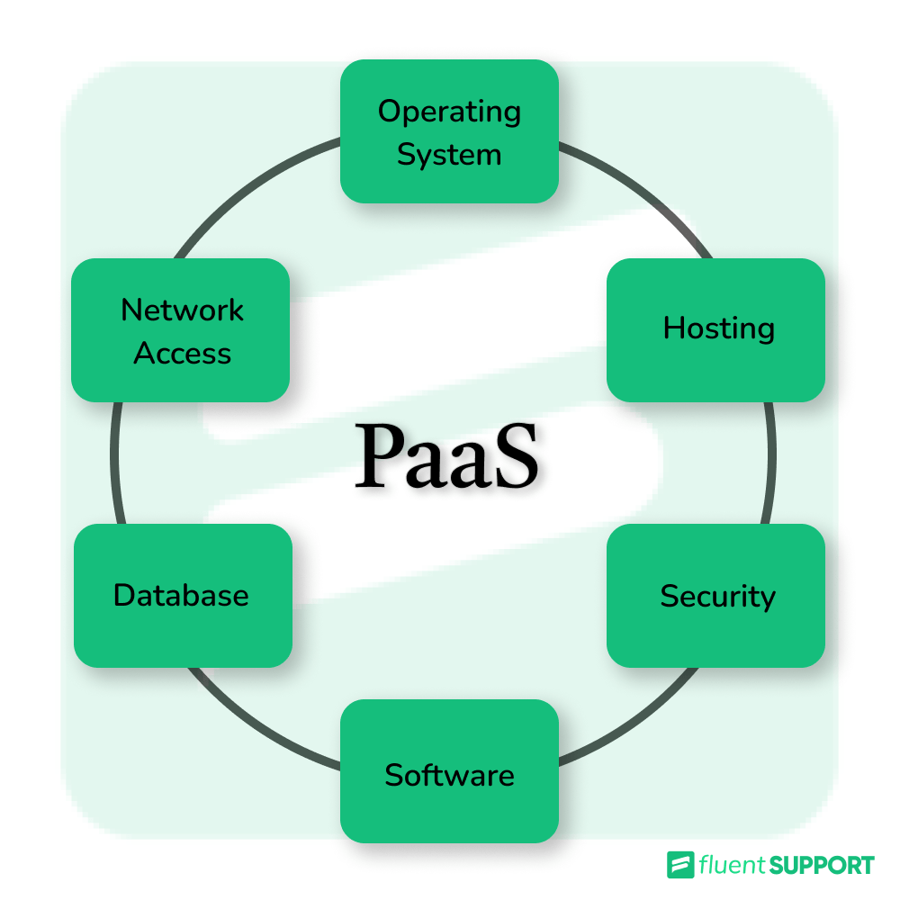
The PaaS platform manages:
. Server setup
. Runtime
. Scaling
. Deployment
. Basic monitoring

Advantages of PaaS
. Faster application development
. No need to manage server OS
. Easy deployment
. Built-in scaling features
. Good for developers

Disadvantages of PaaS
. Less control than IaaS
. Platform dependency
. Vendor lock-in risk
. Limited customization

Best Use Cases of PaaS
. Web application development
. API development
. Mobile backend
. Rapid prototyping
. Developer-friendly application hosting

C. SaaS: Software as a Service
Meaning
SaaS provides complete ready-to-use software through the internet.
The user does not manage server, operating system, database, or application code.
The user only uses the software.

Simple Example
A teacher uses Google Docs to prepare notes.
The teacher does not manage:
. Server
. Storage system
. Software installation
. Updates
. Database
Google manages everything.
Examples:
. Gmail
. Google Docs
. Microsoft 365
. Zoom
. Salesforce
. Canva
. Dropbox
. Google Classroom

SaaS Responsibility Example
Component | Managed By
Data center | Cloud provider
Server | Cloud provider
Operating system | Cloud provider
Application | Cloud provider
Updates | Cloud provider
User data and access | Shared / Customer controls access

SaaS Example in Education
A college uses Google Workspace.
Need | SaaS Tool
Email | Gmail
Online class | Google Meet
File storage | Google Drive
Notes | Google Docs
Assignment | Google Classroom
Spreadsheet | Google Sheets

SaaS Licensing Data Example
A college has 80 staff members.
Cloud office software cost = Rs. 700 per user per month.
Monthly Cost = Number of Users × Cost per User
Monthly Cost = 80 × 700
Monthly Cost = Rs. 56,000
Yearly cost:
Yearly Cost = 56,000 × 12
Yearly Cost = Rs. 672,000

Advantages of SaaS
. Easy to use
. No installation required
. Accessible from anywhere
. Automatic updates
. Low technical maintenance
. Good for collaboration

Disadvantages of SaaS
. Less customization
. Internet dependency
. Subscription cost
. Data privacy concern
. Vendor dependency

Best Use Cases of SaaS
. Email
. Online office tools
. CRM
. Video conferencing
. Accounting software
. Learning management systems

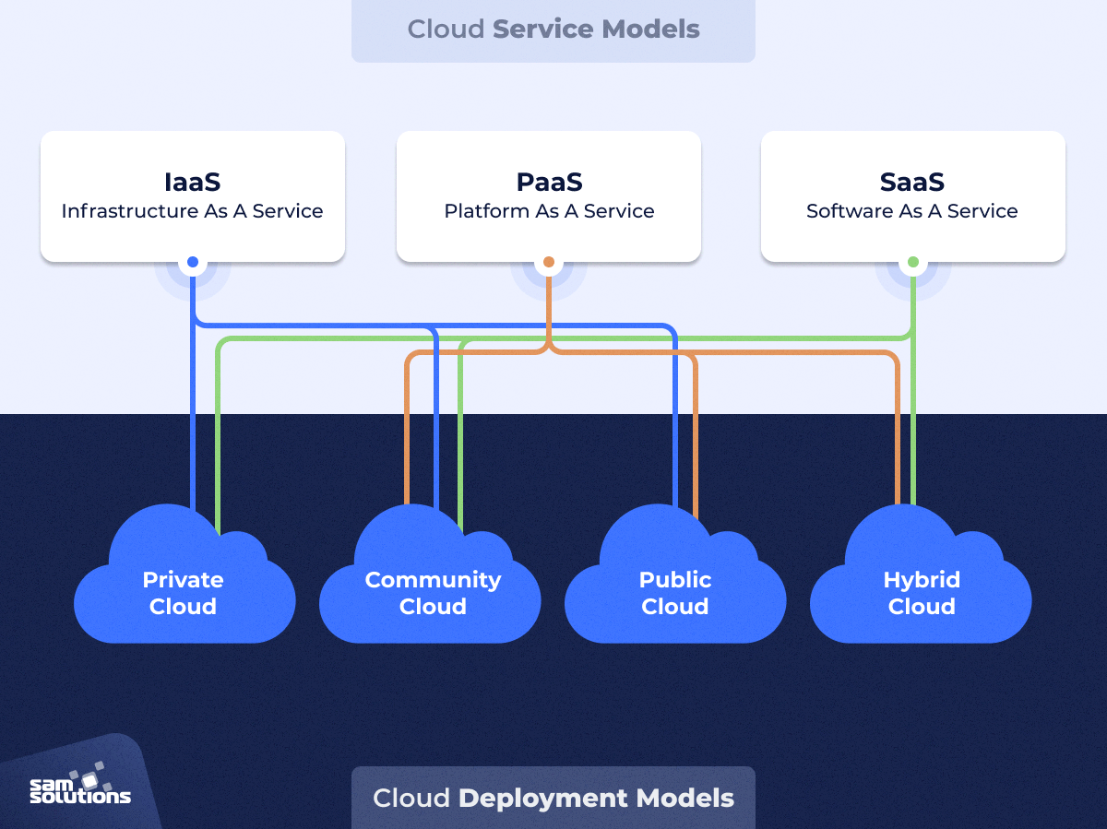
. 2.2 Deployment models:

Deployment model explains where and how cloud infrastructure is deployed.
Major deployment models are:
. Public cloud
. Private cloud
. Hybrid cloud
. Community cloud
A. Public Cloud
Meaning: Public cloud is cloud infrastructure owned and managed by a cloud service provider and shared among many customers.
Users access services through the internet.
Examples:
. AWS
. Microsoft Azure
. Google Cloud
. Oracle Cloud
. IBM Cloud

Public Cloud Example
A startup hosts its e-commerce website on AWS.
It uses:
. AWS EC2 for server
. AWS S3 for image storage
. AWS RDS for database
. CloudFront for content delivery
The startup does not own the physical data center.

Advantages of Public Cloud
. Low initial cost
. Highly scalable
. Easy to start
. Global availability
. Pay-as-you-use pricing

Disadvantages of Public Cloud
. Less direct control
. Data privacy concern
. Compliance issues for sensitive data
. Internet dependency
. Vendor lock-in risk

Best Use Cases
. Website hosting
. Startups
. Online applications
. Backup storage
. Testing and development
. Public-facing applications

B. Private Cloud
Meaning
Private cloud is cloud infrastructure used by only one organization.
It may be located:
. Inside the organization’s own data center
. In a hosted private cloud facility

Private Cloud Example
A bank builds its own private cloud to manage customer records, internal banking applications, and transaction systems.
The infrastructure is not shared with other companies.

Advantages of Private Cloud
. More control
. Better privacy
. Better customization
. Suitable for sensitive data
. Easier compliance management

Disadvantages of Private Cloud
. High initial cost
. Requires skilled IT team
. Maintenance responsibility
. Scaling may be expensive

Best Use Cases
. Banking
. Government systems
. Military systems
. Hospitals with sensitive records
. Large enterprises with strict compliance

C. Hybrid Cloud
Meaning
Hybrid cloud combines private cloud and public cloud.
Some systems run in private cloud, and some systems run in public cloud.

Hybrid Cloud Example
A hospital stores patient records in a private cloud but uses public cloud for website, email, and appointment booking.
Sensitive patient records → Private cloud
Public website and email → Public cloud

Advantages of Hybrid Cloud
. Balance between security and scalability
. Sensitive data can stay private
. Public cloud can handle extra workload
. Flexible cost management
. Good disaster recovery option

Disadvantages of Hybrid Cloud
. Complex management
. Requires strong integration
. Security policy must be carefully designed
. Network connectivity is important

Best Use Cases
. Hospitals
. Banks
. Universities
. Government offices
. Large businesses with mixed workloads

D. Community Cloud
Meaning
Community cloud is shared by organizations with similar needs, policies, or goals.
It is used by a specific community, not by the general public.

Community Cloud Example
Several government departments share one cloud infrastructure for citizen services.
Another example:
Several universities share a research cloud for academic data and simulations.

Advantages of Community Cloud
. Shared cost
. Common security policy
. Suitable for similar organizations
. Better collaboration
. Industry-specific compliance

Disadvantages of Community Cloud
. Limited scalability compared to public cloud
. Governance may be difficult
. Cost is higher than public cloud
. Shared responsibility can be complex

Best Use Cases
. Government departments
. Research institutions
. Healthcare networks
. Educational institutions
. Banking associations

2.3 Comparison of Service Models
IaaS vs PaaS vs SaaS
Feature | IaaS | PaaS | SaaS
Full Form | Infrastructure as a Service | Platform as a Service | Software as a Service
Main Service | Virtual hardware | Development platform | Ready-made software
User Manages | OS, app, data | App and data | Mostly data and user access
Provider Manages | Hardware, virtualization | Hardware, OS, runtime | Almost everything
Control | High | Medium | Low
Technical Skill Needed | High | Medium | Low
Example | AWS EC2 | Heroku | Gmail
User Type | System admin, DevOps | Developer | End user
Customization | High | Medium | Low
Deployment Speed | Medium | Fast | Very fast

Simple Analogy
Model | Analogy | Explanation
IaaS | Renting empty land | You build everything yourself
PaaS | Renting a ready kitchen | You cook your own food
SaaS | Eating at restaurant | You just use the final service

Responsibility Comparison
Layer | IaaS | PaaS | SaaS
Application | Customer | Customer | Provider
Data | Customer | Customer | Shared
Runtime | Customer | Provider | Provider
Middleware | Customer | Provider | Provider
Operating System | Customer | Provider | Provider
Virtualization | Provider | Provider | Provider
Server Hardware | Provider | Provider | Provider
Network | Provider | Provider | Provider
Data Center | Provider | Provider | Provider

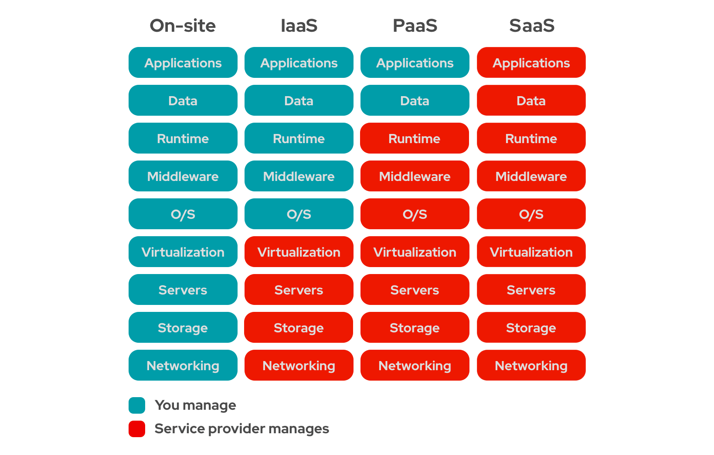
. 2.3 Comparison of service models

IaaS vs PaaS vs SaaS
Feature | IaaS | PaaS |  | SaaS
Full Form | Infrastructure as a Service | Platform as a Service |  | Software as a Service
Main Service | Virtual hardware | Development platform |  | Ready-made software
User Manages | OS, app, data | App and data |  | Mostly data and user access
Provider Manages | Hardware, virtualization | Hardware, OS, runtime |  | Almost everything
Control | High | Medium |  | Low
Technical Skill Needed | High | Medium |  | Low
Example | AWS EC2 | Heroku |  | Gmail
User Type | System admin, DevOps | Developer |  | End user
Customization | High | Medium |  | Low
Deployment Speed | Medium | Fast |  | Very fast

Simple Analogy
Model | Analogy | Explanation
IaaS | Renting empty land | You build everything yourself
PaaS | Renting a ready kitchen | You cook your own food
SaaS | Eating at restaurant | You just use the final service

Responsibility Comparison
Layer | IaaS | PaaS | SaaS
Application | Customer | Customer | Provider
Data | Customer | Customer | Shared
Runtime | Customer | Provider | Provider
Middleware | Customer | Provider | Provider
Operating System | Customer | Provider | Provider
Virtualization | Provider | Provider | Provider
Server Hardware | Provider | Provider | Provider
Network | Provider | Provider | Provider
Data Center | Provider | Provider | Provider

. 2.4 Shared responsibility model
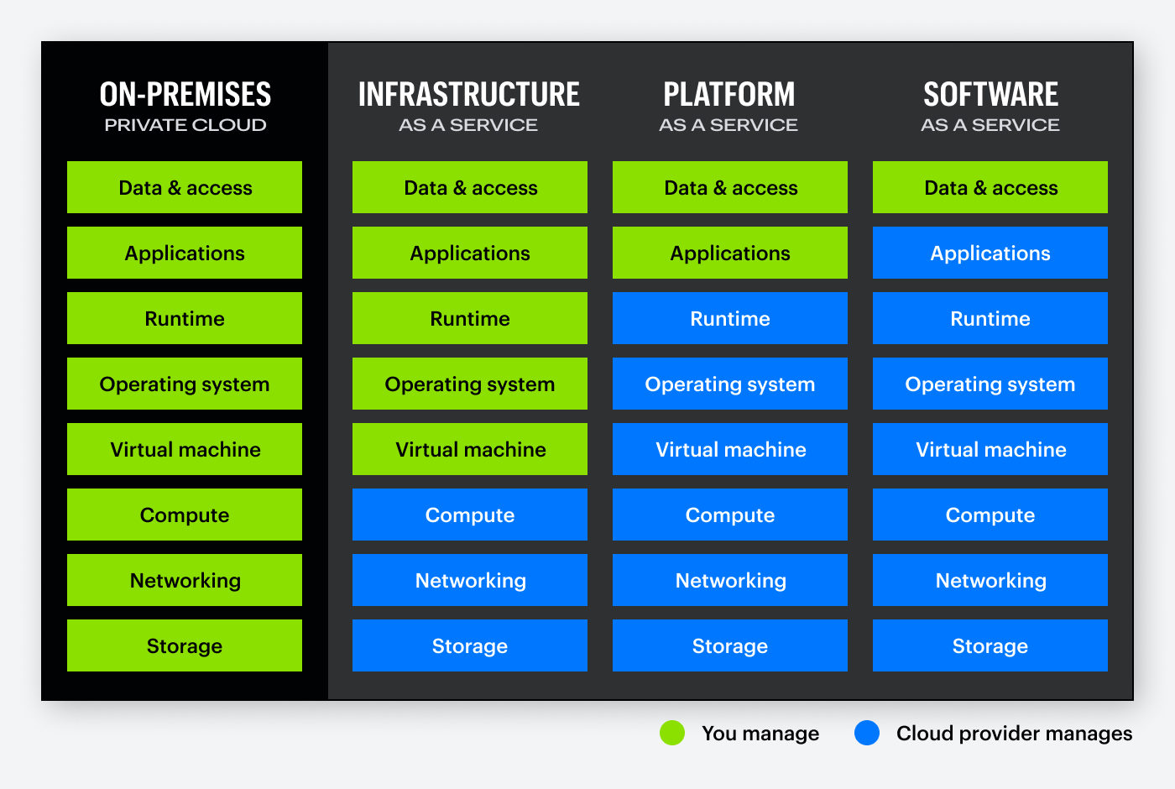
Meaning
The shared responsibility model explains which security and management tasks are handled by the cloud provider and which are handled by the customer.
In cloud computing, security is not only the provider’s responsibility. The customer also has responsibilities.
Basic Idea
Cloud Provider = Security OF the cloud
Customer = Security IN the cloud
Provider Responsibilities
The cloud provider is usually responsible for:
. Physical data center security
. Physical servers
. Storage hardware
. Network hardware
. Power and cooling
. Virtualization layer
. Cloud infrastructure availability

Customer Responsibilities
The customer is usually responsible for:
. User accounts
. Passwords
. Access permissions
. Application security
. Data security
. Operating system patching in IaaS
. Firewall rules
. Backup configuration
. Compliance settings

Shared Responsibility by Service Model
Responsibility | IaaS | PaaS | SaaS
Physical security | Provider | Provider | Provider
Network hardware | Provider | Provider | Provider
Virtualization | Provider | Provider | Provider
Operating system | Customer | Provider | Provider
Runtime | Customer | Provider | Provider
Application | Customer | Customer | Provider
Data | Customer | Customer | Shared
User access | Customer | Customer | Customer
Password policy | Customer | Customer | Customer

Example 1: IaaS Responsibility
A company rents an Ubuntu VM from a cloud provider.
Provider manages:
. Physical server
. Data center
. Virtualization
. Physical network
Customer manages:
. Ubuntu updates
. Nginx configuration
. Database password
. Firewall rules
. Application security
. User accounts

Example 2: SaaS Responsibility
A college uses Google Classroom.
Provider manages:
. Application
. Server
. Storage system
. Updates
. Platform security
College manages:
. Teacher accounts
. Student accounts
. Passwords
. Sharing permissions
. Class access control

Common Security Mistake
A user stores sensitive files in cloud storage and sets permission to:
Anyone with the link can view
Even if the cloud provider is secure, the data becomes exposed due to wrong customer configuration.
This shows why shared responsibility is important.

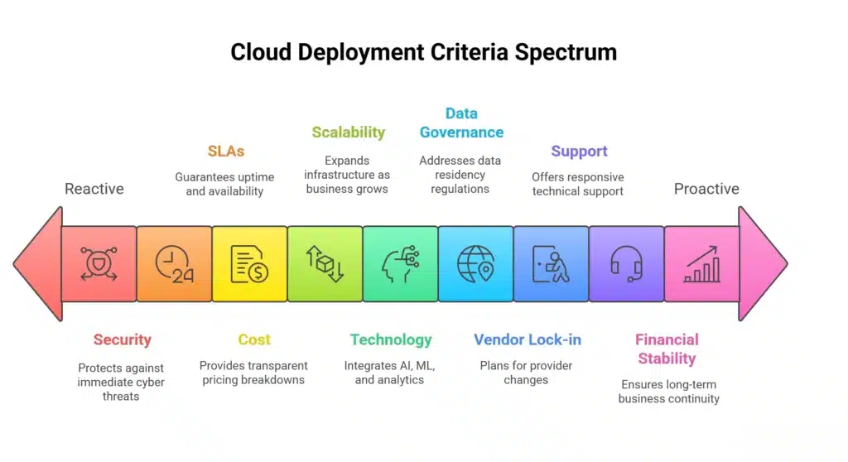
. 2.5 Selection criteria
Meaning
Selection criteria are the factors used to choose the correct cloud service model and deployment model.

Main Selection Factors
. Cost
. Security
. Control
. Scalability
. Technical skill
. Compliance
. Performance
. Customization
. Data sensitivity
. Migration complexity
. Vendor support
. Availability requirement

Selecting Service Model
Requirement | Suitable Model | Reason
Need full control over OS | IaaS | Customer manages server OS
Need to develop app quickly | PaaS | Platform handles runtime
Need ready-made email | SaaS | Complete software available
Need custom database tuning | IaaS | More control
Need simple office tools | SaaS | No technical setup
Need app deployment without server management | PaaS | Developer-focused

Selecting Deployment Model
Requirement | Suitable Model | Reason
Low cost and fast start | Public cloud | Easy and scalable
Sensitive data and strict control | Private cloud | More privacy
Mix of sensitive and public workloads | Hybrid cloud | Balanced model
Similar organizations sharing needs | Community cloud | Shared policy and cost

Scenario-Based Examples

Scenario 1: Small Startup Website
A startup wants to host an online shopping website with limited budget.
Best choice:
Service Model: IaaS or PaaS
Deployment Model: Public Cloud
Reason:
. Low initial cost
. Easy scaling
. No physical server required
. Fast deployment

Scenario 2: Hospital Patient Record System
A hospital wants to store patient records securely.
Best choice:
Service Model: IaaS or Private SaaS
Deployment Model: Private Cloud or Hybrid Cloud
Reason:
. Sensitive patient data
. Privacy requirement
. Controlled access needed
. Backup and disaster recovery important

Scenario 3: College Email and Document System
A college wants email, document sharing, and online class tools.
Best choice:
Service Model: SaaS
Deployment Model: Public Cloud
Reason:
. Ready-made software
. Easy to use
. No server maintenance
. Supports collaboration

Scenario 4: Software Company Building API

A software company wants to develop and deploy REST API quickly.
Best choice:
Service Model: PaaS or Container Platform
Deployment Model: Public Cloud
Reason:
. Developer can focus on code
. Platform manages runtime
. Easy deployment
. Auto scaling possible

Scenario 5: Government Citizen Data System
A government department wants a secure citizen database.
Best choice:
Service Model: IaaS or Private Cloud Platform
Deployment Model: Private Cloud or Community Cloud
Reason:
. Sensitive data
. Compliance requirement
. More control required
. Shared government infrastructure possible

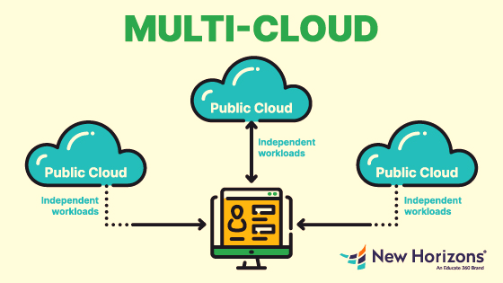
. 2.6 Multi-cloud concepts
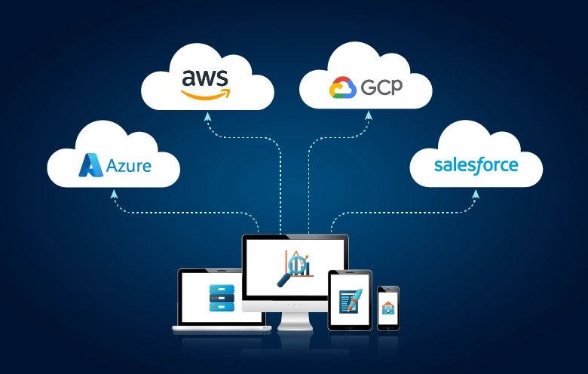

Meaning of Multi-Cloud
Multi-cloud means using cloud services from more than one cloud provider.
Example:
A company uses AWS for web hosting,
Google Cloud for data analytics,
and Microsoft Azure for office identity services.

Multi-Cloud Architecture Example
Users
↓
Application on AWS
↓
Data Analytics on Google Cloud
↓
Authentication through Microsoft Azure

Why Organizations Use Multi-Cloud
. Avoid dependency on one provider
. Use best service from each provider
. Improve availability
. Reduce outage risk
. Meet regional or legal requirements
. Optimize cost
. Improve disaster recovery

Multi-Cloud Example in Business
A company uses:
Workload | Cloud Provider
Website hosting | AWS
Office email | Microsoft 365
Data analytics | Google Cloud
Backup storage | Wasabi / Backblaze
Video meeting | Zoom
This is a multi-cloud environment.

Advantages of Multi-Cloud
. Reduces vendor dependency
. Improves flexibility
. Allows best-of-breed services
. Better disaster recovery
. Can improve negotiation power

Challenges of Multi-Cloud
. Complex management
. Different billing systems
. Different security policies
. Skill requirement increases
. Monitoring becomes harder
. Data transfer cost may increase

Data Example: Multi-Cloud Cost
A company uses two cloud providers.
Service | Provider | Monthly Cost
Web hosting | AWS | Rs. 20,000
Email | Microsoft 365 | Rs. 15,000
Analytics | Google Cloud | Rs. 12,000
Backup | Backblaze | Rs. 5,000
Total monthly cost:
20,000 + 15,000 + 12,000 + 5,000 = Rs. 52,000
Yearly cost:
52,000 × 12 = Rs. 624,000

. 2.7 Vendor lock-in issues
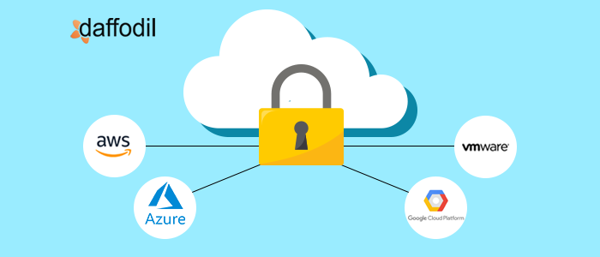
Meaning of Vendor Lock-In
Vendor lock-in means becoming highly dependent on one cloud provider, making it difficult, costly, or risky to move to another provider.

Simple Example
A company builds its application using many provider-specific services.
Example:
. AWS Lambda
. AWS DynamoDB
. AWS S3
. AWS API Gateway
Later, if the company wants to move to Azure or Google Cloud, it must redesign many parts of the application.

Causes of Vendor Lock-In
. Provider-specific APIs
. Proprietary databases
. Special serverless functions
. Specific storage format
. Licensing restrictions
. Data transfer cost
. Lack of documentation
. Application tightly connected with one provider

Vendor Lock-In Example
A company uses a cloud database that is only available in one provider.
Problem Area | Effect
Database syntax | May not work in another cloud
API dependency | Code must be rewritten
Data migration | Takes time and cost
Staff skill | Team must learn new platform
Downtime risk | Migration may interrupt service

Data-Based Example: Migration Cost
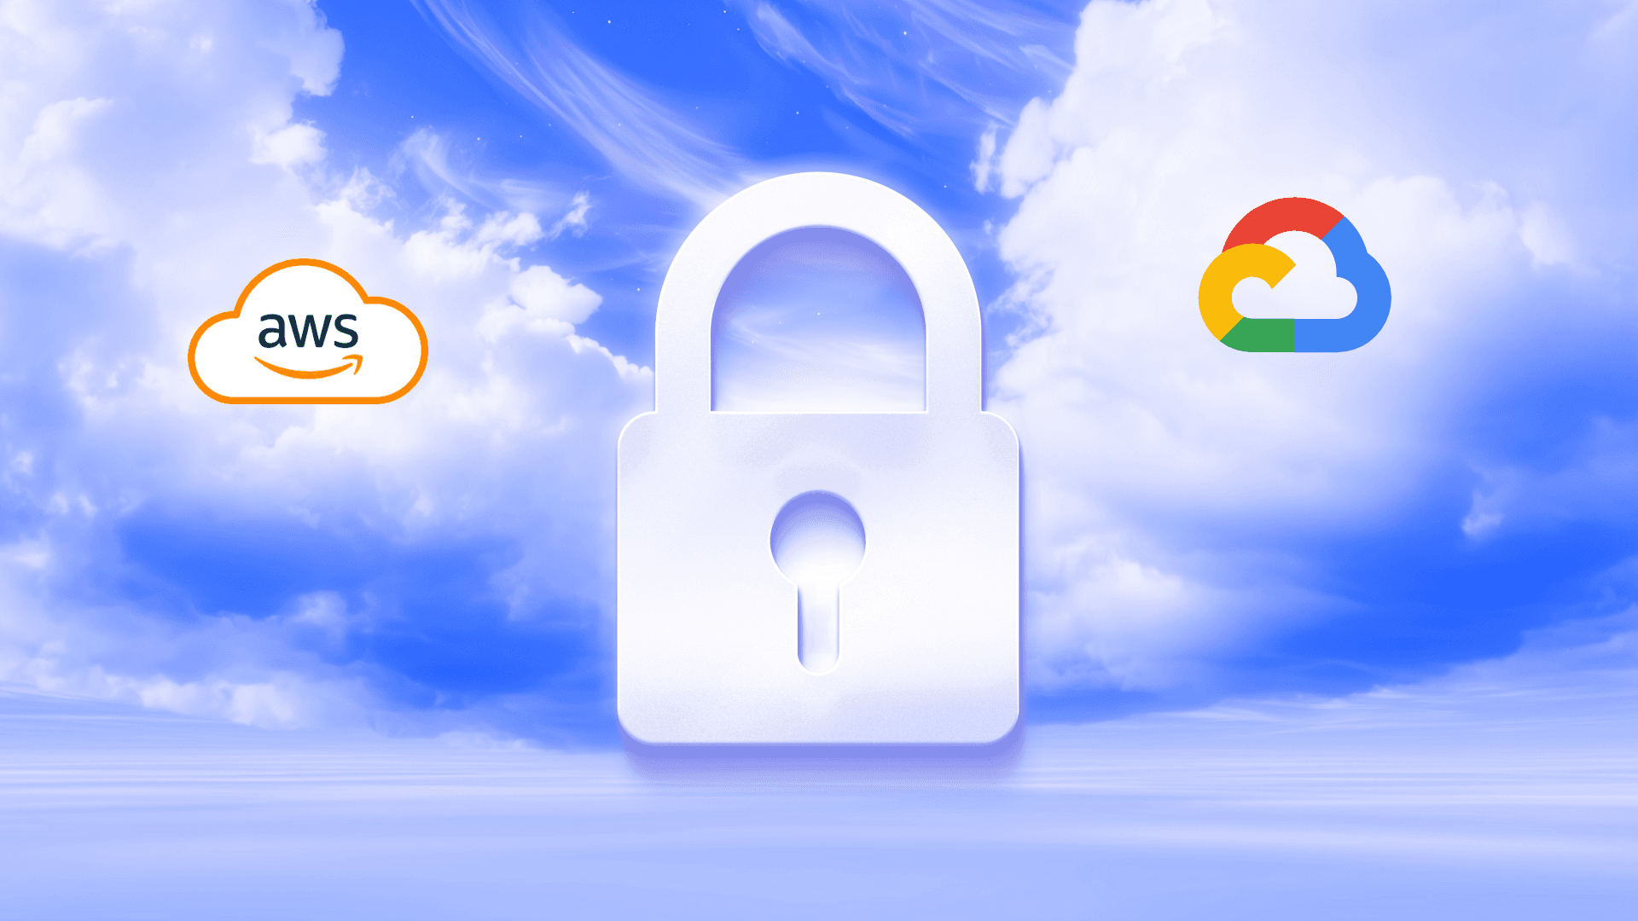
A company wants to move from Cloud A to Cloud B.
Migration Activity | Estimated Cost
Data export | Rs. 50,000
Developer code changes | Rs. 300,000
Testing | Rs. 100,000
Training | Rs. 80,000
Downtime loss | Rs. 150,000
Total migration cost:
50,000 + 300,000 + 100,000 + 80,000 + 150,000
= Rs. 680,000
This high cost is an example of vendor lock-in impact.

How to Reduce Vendor Lock-In
. Use open standards.
. Use containers such as Docker.
. Use Kubernetes.
. Use standard databases like PostgreSQL or MySQL.
. Avoid unnecessary provider-specific services.
. Keep backup copies in standard formats.
. Use Infrastructure as Code.
. Document architecture properly.
. Design application with portability in mind.

Vendor Lock-In vs Multi-Cloud
Topic | Vendor Lock-In | Multi-Cloud
Meaning | Dependency on one provider | Use of multiple providers
Risk | Difficult migration | Complex management
Main Problem | Lack of flexibility | Operational complexity
Solution | Open standards, containers | Unified monitoring and governance

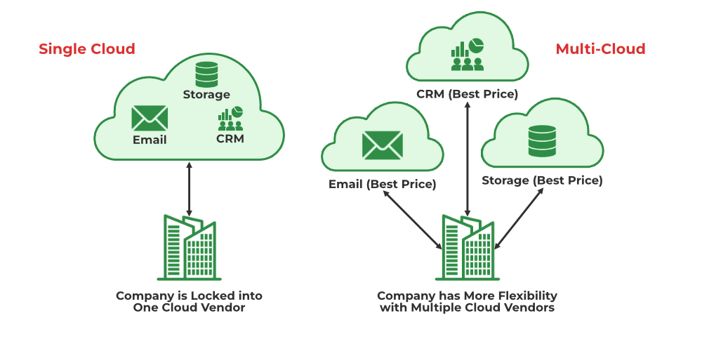

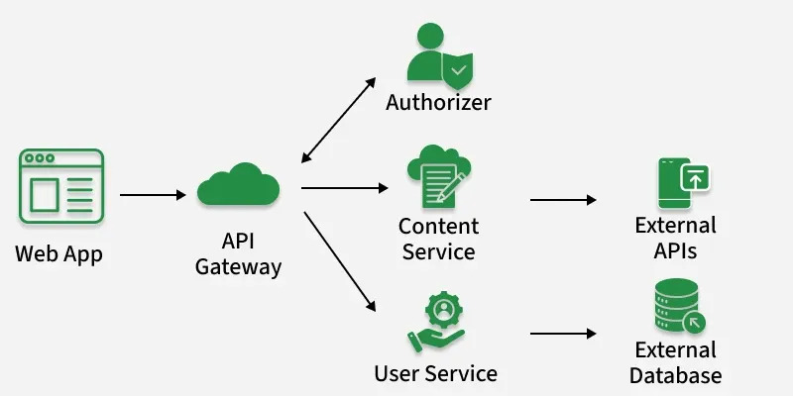
. 2.8 Serverless computing and event-driven architecture

Serverless Computing
Meaning
Serverless computing is a cloud model where developers run code without managing servers.
The cloud provider automatically manages:
. Server provisioning
. Runtime
. Scaling
. Availability
. Infrastructure maintenance
Serverless does not mean there is no server. It means the customer does not manage the server.

Serverless Examples
. AWS Lambda
. Azure Functions
. Google Cloud Functions
. Cloudflare Workers
. Vercel Functions

Serverless Example Scenario
A college has an online admission form.
When a student submits the form, a function automatically:
. Validates the form
. Saves data to database
. Sends confirmation email
. Sends notification to admission officer
The function runs only when a form is submitted.

Serverless Benefits
. No server management
. Auto scaling
. Pay only when function runs
. Good for event-based tasks
. Faster development

Serverless Challenges
. Cold start delay
. Limited execution time
. Vendor lock-in risk
. Debugging can be difficult
. Not suitable for long-running applications

Event-Driven Architecture
Meaning
Event-driven architecture is a design model where system components communicate by producing and responding to events.
An event is an action or change in the system.
Examples of events:
. User registered
. Payment completed
. File uploaded
. Order placed
. Sensor data received
. Database record updated

Event-Driven Flow
Event Occurs
↓
Event Trigger
↓
Function / Service Executes
↓
Result / Action

Example: Online Shopping Event Flow
Customer places order
↓
Order Created Event
↓
Inventory Service updates stock
↓
Payment Service checks payment
↓
Notification Service sends SMS/email
↓
Delivery Service creates shipment

Event-Driven Architecture Components
Component | Meaning
Event Producer | Creates event
Event | Action/change information
Event Broker | Transfers event
Event Consumer | Receives and processes event
Function | Code executed after event

Data-Based Example: Admission Form
A college receives admission forms.
Time | Forms Submitted
9 AM | 10
10 AM | 25
11 AM | 40
12 PM | 75
1 PM | 30
Each form triggers one serverless function.
Total function executions:
10 + 25 + 40 + 75 + 30 = 180 executions
If cost per 1,000 executions is Rs. 20:
Cost = (180 ÷ 1000) × 20
Cost = Rs. 3.60
This shows serverless can be cost-effective for event-based workloads.

Simple Python Event-Driven Example
def admission_event_handler(event):
student_name = event["student_name"]
program = event["program"]
message = f"Application received from {student_name} for {program}."
return message
event_data = {
"student_name": "Ram Thapa",
"program": "BSc CSIT"
}
result = admission_event_handler(event_data)
print(result)
Output:
Application received from Ram Thapa for BSc CSIT.

Serverless vs Traditional Server
Feature | Traditional Server | Serverless
Server management | Customer manages | Provider manages
Scaling | Manual or configured | Automatic
Cost | Pay while server runs | Pay per execution
Best for | Long-running apps | Event-based tasks
Startup | Always running | May have cold start
Control | More control | Less control

When to Use Serverless
Use serverless for:
. Form submission processing
. Image resizing
. Email notification
. Scheduled jobs
. Payment confirmation
. Log processing
. IoT sensor processing

When Not to Use Serverless
Avoid serverless when:
. Application must run continuously
. Long processing time is required
. Full server control is needed
. Very low-latency response is required
. Heavy custom runtime is required

Practical Commands and Small Programs
1. Run a Simple Web Server on IaaS VM
Assume Ubuntu VM is rented from cloud.
Install Nginx:
sudo apt update
sudo apt install nginx -y
sudo systemctl start nginx
sudo systemctl enable nginx
Check status:
sudo systemctl status nginx
Test locally:
curl http://localhost

2. Deploy Simple App Using Docker
Create folder:
mkdir cloud-service-demo
cd cloud-service-demo
Create index.html:
nano index.html
Paste:
<!DOCTYPE html>
<html>
<head>
<title>Cloud Service Model Demo</title>
</head>
<body>
<h1>Hello Cloud Service Models</h1>
<p>This application is running inside a Docker container.</p>
</body>
</html>
Create Dockerfile:
nano Dockerfile
Paste:
FROM nginx:latest
COPY index.html /usr/share/nginx/html/index.html
Build image:
docker build -t cloud-service-demo .
Run container:
docker run -d -p 8080:80 --name service-demo cloud-service-demo
Open:
http://localhost:8080
Stop:
docker stop service-demo
docker rm service-demo

3. Simple Event-Driven Program
def payment_event(event):
customer = event["customer"]
amount = event["amount"]
status = event["status"]
if status == "success":
return f"Payment of Rs. {amount} received from {customer}. Send receipt."
else:
return f"Payment failed for {customer}. Send retry message."
event = {
"customer": "Sita Sharma",
"amount": 2500,
"status": "success"
}
print(payment_event(event))
Output:
Payment of Rs. 2500 received from Sita Sharma. Send receipt.

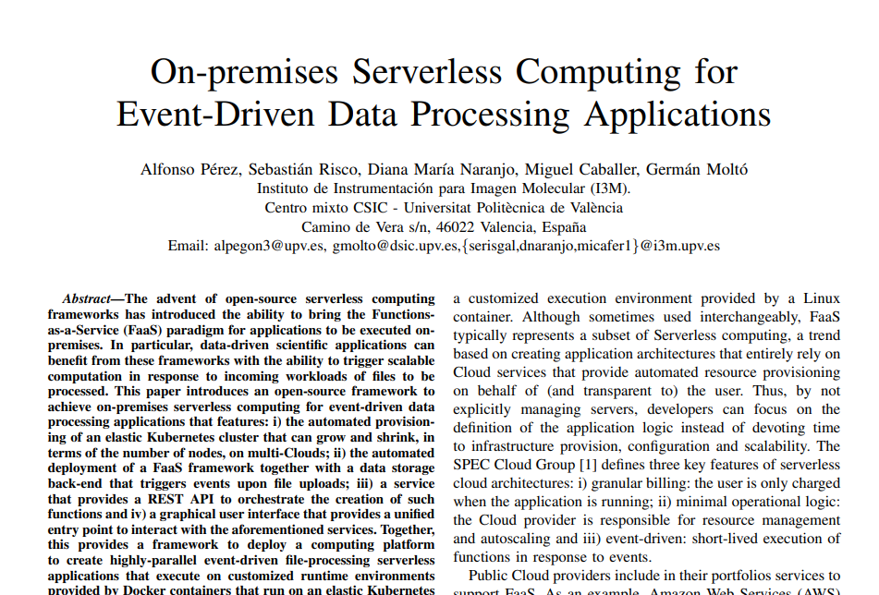
PAPER
https://www.grycap.upv.es/gmolto/publications/preprints/Perez2019osc.pdf

5 short presentation topics for this paper:
1. Serverless Computing and FaaS Basics
Explain what serverless computing is and how Function-as-a-Service works.
2. Problem with Public Cloud Serverless
Discuss limits of AWS Lambda-like platforms, such as execution time, storage limits, and less control.
3. OSCAR Framework
Introduce OSCAR as an open-source, on-premises serverless framework for data-processing applications.
4. OSCAR Architecture and Workflow
Explain how Kubernetes, OpenFaaS, MinIO, Kaniko, and CLUES work together to process files automatically.
5. Case Study and Results
Explain the video object-detection experiment and how OSCAR handled workloads using elastic scaling.

